Game Concepts

1:

My first game concept will invlove two players on various points of a map, the map will contain pickup items such as a coins and may contain obstacles, the game will be a competition to obtain the most coins in a set number of turns (E.g. collect more coins then your opponant in 10 turns) Other mechanics could involve hitting your opponant from behind to steal coins or knocking them into traps to cause them to lose coins. The games control scheme will involve a direction idicated circling around the player, when the screen is tapped the player will launch themselves in the direction that the arrow is pointing in, after the characters have been static for a short time then the next players turn commences. This game would be competitive as players are both trying to collect coins and protect themselves from the other player. The player characters will most likely be small circles which lend themselves to having a cute design which is popular with the casual gaming market. The game will test users accuracy and timing, the game will be very leniant with traps to make it more friendly for casual players.

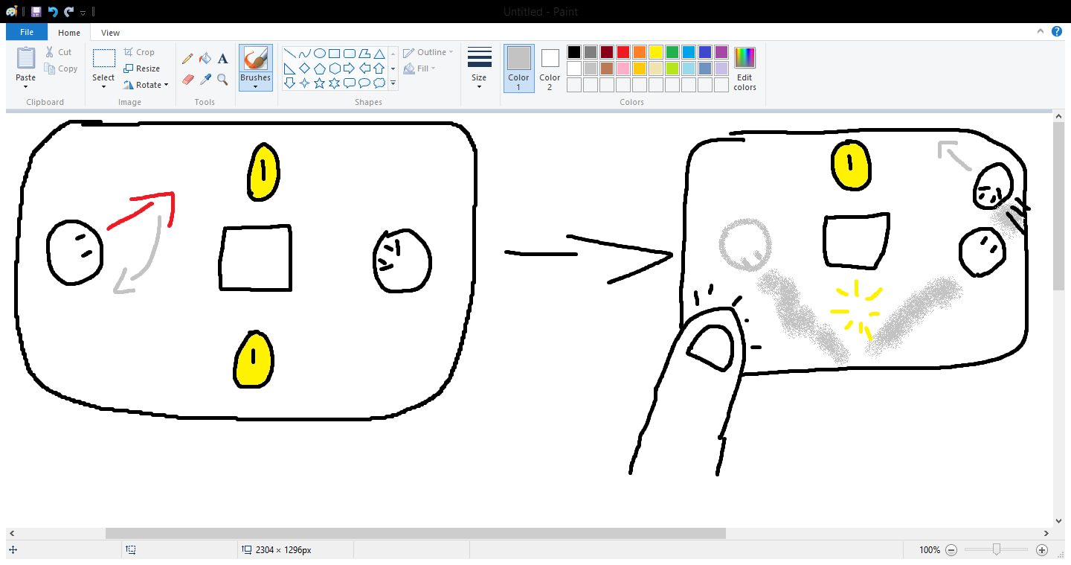

2:

The second game I have concept I have thought of is a simple game based of a popular board game battleships, the first player will place an icon in a 3 by 3 grid, after this its location will be hidden and the second players turn will begin, the second player will choose a slot on the grid to put a bomb which if placed on the spot where the first player has hidden their icon the second player will win, however if they place it in a different location then that square will become unusable, after placing the bomb, assuming the player is unsucsessful the second player will now need to place their own icon somewhere on the board, at this point player 1 then has to attempt to find it, if they do not they are offered the oppitunity to place there icon on a different spot. The game continues until a player wins or all but one slot on the board have been rendered unusable; in this senario it would be considered a tie. This game will have a larger enphesis on luck as the only way the other player could work out where the players icon is by narrowing it down to spots which are still usable. If this is too simple other mechanic such as gaining points for not moving or filling in certain paterns could be implimented to have a scoring system. This game is inspired by batttleships which is already a popular game which could make this game appeal to casual gamers more, the 3 by 3 grid is also remenisent of noughts and crosses which may also appeal to casual gamers.

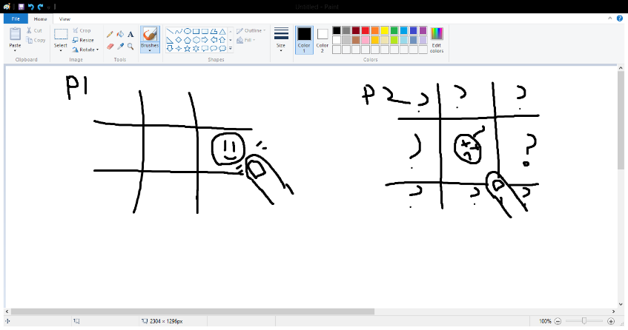

3:

The next game concept I have thought up involves two players taking it in turns to remove blocks from a tower, when one player takes their go they will take a block in the tower and it will disappear, the blocks above it will then fall using physics, their turn will not end until the blocks stop moving; at this point the second player will take their turn. The goal is to not knock the character of the top of the tower, if the character at the top of the tower falls off or is crushed then the player responsible for this will lose the game. This game would need a large variety of stages or potentially randomly generated stages to keep the game fresh and to prevent a player from finding a dominant strategy for every stage, the game could also feature special blocks that act differently like glass which could break by other blocks falling on it, explosives which explode rather than disappearing or metal blocks which weigh more than others causing them to react differently, a winner is declared when the character has fallen or been crushed however in the scenario that this become impossible then the game will be considered a tie when neither player can destroy anything else. This game is also somewhat inspired by a popular casual game, that being Jenga when the goal is also to prevent a tower from falling over however the tower in this game will not be an even and consistent tower like the one in Jenga. This game would require a cartoonish art style as a character risks being crushed which outside of a cartoonish art style would be very gruesome however when done in a cartoony way (E.g. disappearing into a cloud of smoke) then the game would be more casual user friendly, this game will also be partially reliant on luck and predicting what might happen which is something used a lot in popular casual games (E.g. Angry Birds)

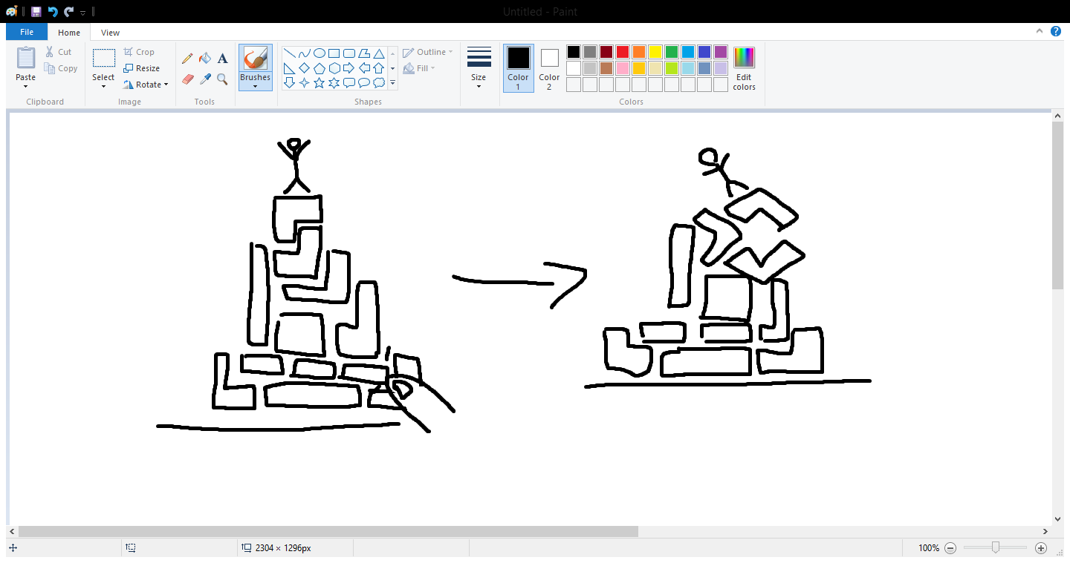

4:

The last game concept I have thought of involves two players being placed in a box filled with walls which can be tapped, when a players turn arrives they will have 3 options on what to do, they can tap infront of their player character, this causes their character to keep moving until it encounters a wall, they can tap on their character; this causes their character to rotate 90 degrees or they can tap on a wall; this causes the wall to rotate 90 degrees. Doing all these things will allow players to navigate the map the goal is to turn lamps on the floor into their own color, depending on the difficulty the player may have to turn all lights to their colour or just the vast majority. The player is not just restricted to moving walls to benefit themselves, they can also sabotage the other player by rotating a wall to block them off or closing an opening to prevent them from getting a light, you can also trigger enemy lights to convert them into your own. The game ends when either the winning number of lights has been aquired by one player or a turn limit has been reached, if this was to happen the player with the most lights will win, if both players have the same number of lights then it will be a tie. Like my other ideas this concept would work well with a cartoony artstlye, a theme that could be used in this game is robots due to the angular design and the single direction movment which could be associated with robots, because of this the game might appeal to casual users; however of the 4 game concepts I have come up with this is the most complex due to the variety of options the player has in their turn; this might put off casual players who are not willing to learn to rules so the game might have to be simplified or a easy to learn tutorial will have to be included.

